**TEAMS**

|  |  |  |
| --- | --- | --- |
| **TEAM** | **MEMBER 1** | **MEMBER 2** |
| 1 | Drew | Max A. |
| 2 | Danny | Kyle |
| 3 | Josef | Max T. |

**VLAN Configuration**

VLAN 1 is untagged across ports 1 and 2, VLAN 11 is untagged across ports 3 and 4, VLAN 12 is untagged across ports 5 and 6. Ports 8, 9, and 10 are tagged trunk ports.

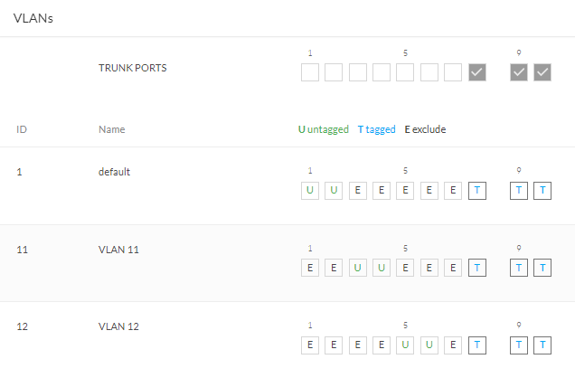

**SAME VLANs**

These pings should be successful, as both hosts are on the same VLAN.

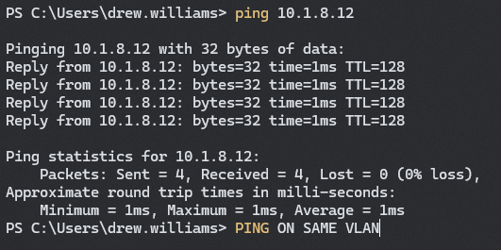

This is me pinging Max A. on the same switch through VLAN 1. I was on port 1 and Max on port 2.

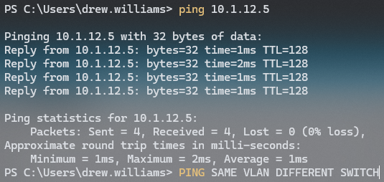

This is me pinging Danny on a different switch through VLAN 12. I was on port 6 and Danny on port 6.

**DIFFERENT VLAN’s**

These pings should be unsuccessful, as the hosts are on different VLAN’s that are not configured to talk to each other.

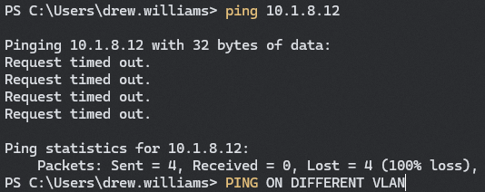

This is me pinging Max A. on the same switch across VLANs. I am on VLAN 1 plugged into port 2, he is on VLAN 11 plugged into port 4.

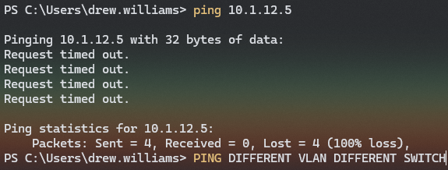

This is me pinging Danny on a different switch through across VLANs. I am on VLAN 1 plugged into port 2, he is on VLAN 12 plugged into port 6.